Copyright for test papers and marking guides remains with *West Australian Test Papers.*

They may only be reproduced within the purchasing school according to the advertised Conditions of Sale.

Test papers should be withdrawn after use and stored securely in the school until Friday 5th December 2014.



## PHYSICS

## YEAR 11

## 2A/2B

**2014**

**SOLUTIONS**

**Section 1: Short Answers**

**Question 1** (4 marks)

1. Function: A fuse is placed within a circuit or parts of a circuit to protect components from currents that are higher than design current. (2 marks)
2. A fuse will only break the circuit at a particular design current, which might be much higher than the modest currents required to injure or kill a person. (2 marks)

*(extra info: Even if a fuse does blow, it is not designed to blow quickly enough to prevent injury or death. An RCD is designed to shut off the current very quickly in order to minimise injury)*

**Question 2** (2 marks)

Q = m c T = 0.5 x (4.18 x 103) x 80 = 1.672 x 105 J

Q = m L = 0.5 x (2.26 x 106) = 1.13 x 106 J

Total quantity of heat = 1.3 x 106 J

**Question 3** (3 marks)

The girl is receiving a very large electrical charge from the machine and because she is insulated from the earth, the charge accumulates on the outside of her body. The dry strands of her hair become individually charged with like charge (most likely negative). The like charge repels each hair so the hair stands up and separate.

**Question 4** (2 marks)

The thermometer with the bulb wrapped in cotton wool would most likely be showing a lower temperature than the other thermometer. For the methylated spirit particles to evaporate from the bulb they require latent heat of vaporisation. Some of this heat is extracted from the liquid in the bulb resulting in a lower temperature being observed in that thermometer. The other thermometer has no similar latent heat being extracted so would show a higher temperature.

**Question 5** (5 marks)

(a) let upwards be positive

u = 0 m s-1

a = ?

v =23 m s-1

s = 33.0 m

v2 = u2 + 2 a s

232 = 02 + 2 x a x 33

529 = 0 + 66 a

66 a = 529

a = 8.02 m s-2 (2 marks)

(b) Total energy at point A = mgh

= 6000 x 9.8 x 30

= 1.764 x 106 J

Total energy at point B = m g h + ½ m v2

= (6000 x 9.8 x 25) + [½ x 6000 x (5000/3600)2]

= 1.47 x 106 + 5.788 x 103

= 1.476 x 106 J

Loss of energy = (1.764 - 1.476) x 106 = 2.88 x 105 J

Percentage energy loss = (2.88 x 105) / (1.764 x 106) x 100

= 16.3% (3 marks)

**Question 6**  (3 marks)

(a)

u = 0 ms-1

v = ?

s = 5.00 m

a = 9.80 m s-2

v2 = u2 + 2 a s

v2 = 02  + 2 x 9.8 x 5 = 98

v = (98)1/2

speed when the branch hits the ground = 9.90 m s-1 (2 marks)

(b)

I = F t = mΔv

F x 0.300 = 120 x 9.9

F = (120 x 9.9) / 0.300

F = 3960 N (1 mark)

**Question 7** (4 marks)

(a)

Work = V q

Work (energy) = (1.6 x 10-19) x (85 x 103)

= 1.36 x 10-14 J (2 marks)

(b)

98/100 of 1.36 x 10-14 = 1.333 x 10-14 J

E = ½ m v2

1.333 x 10-14 = ½ x 9.11 x 10-31 x v2

v2 = 1.333 x 10-14 x 2 / (9.11 x 10-31)

v2 = 2.92601 x 1016

v = 1.72 x 108 m s-1 (2 marks)

**Question 8** (4 marks)

(a)

They will likely both be at the same temperature. After a night with no heat source, everything in the room should be in thermal equilibrium. (2 marks)

(b)

Tiles are better thermal conductors than the air-filled wool carpet. As heat flows from the boy’s feet to the tiles, it is quickly conducted away into neighbouring parts of the floor, allowing heat to keep flowing from the boy. He feels this flow of heat out as ‘coldness’. (or similar answer focusing on the wool carpet) (2 marks)

**Question 9** (5 marks)

(a)

I = q/t = 2.5 = q / (3.0 x 60 x 60)

Quantity of charge (q) = 2.5 x (3.0 x 60 x 60)

= 2.70 x 104 C (2 marks)

(b)

Number of electrons = q / (1.6 x 10-19)

= 2.70 x 104 / (1.6 x 10-19)

=1.69 x 1023 electrons (1 mark)

(c)

Work = 18 x 2.5 x (3 x 60 x 60)

Work done in moving the charge = 4.86 x 105 J (2 marks)

**Question 10** (4 marks)

(a)

The earth pin is connected to the earth wire which in turn is connected to a conducting component in the appliance. In the event of an active wire accidently touching the conducting component of the appliance, the current will run to earth rather than through the user, thus preventing an electric shock. (2 marks)

(b)

Appliances that are made mainly of non conducting materials and constructed in such a way that even if an active wire touched the body of the appliance it would be unlikely that the current would flow to the user of the appliance. (2 marks)

**Question 11** (4 marks)

(a)

It is most likely the 4WD has been designed with a crumple zone at the front which absorbs the impact force of a collision rather than the force being transmitted to the passenger compartment. The time that the force acts is extended thus reducing the impulsive force

eg. (I = F t) where F is the impulsive force. (2 marks)

(b)

 momentum = momentum before the impact – momentum after the impact

 p = m v - m u

= (2500 x 18) - (2500 x 0)

Change in momentum = 4.5 x 104 kg m s-1 (2 marks)

**Question 12** (4 marks)

(a)

The number of half lives = 3

If one half life is 1.28 x109 years

Three half lives = 3 x 1.28 x 109

= 3.84 x 109 years. (2 marks)

(b)

An extremely long half life would mean that only a very slight change in the mass or activity would be observable in a short period of time. This would be difficult to measure and distinguish from minor changes in background radiation. (2 marks)

**Question 13**  (8 marks)

(a)

Equation 1 131I53 🡪 131Xe54 +  (2 marks)

(b)

Equation 2 131Xe54 🡪 131Xe54 +  (2 marks)

(b)

Iodine-131 has a relatively short half life so will not be active in the body for long (2 marks)

(c)

(0.008 x 20) + (0.012 x 1)

0.16 + 0.012 = 0.172 mSv

In 25 days the dose equivalent is 25 x 0.172 = 4.3 mSv (2 marks)

**Question 14** (4 marks)

Estimate the area of the girl exposed to the Sun = 1.6 x 0.3 = 0.48 m2

Estimate mass of girl = 50 kg

Radiation reaching her per second = 900 x 0.48 = 432 J

Heat from Sun = Heat absorbed by girl

432 x time = m c T

432 x time = 50 x 3500 x 2

time = (50 x 3500 x 2) / 432

time =810 s = 13.50 min

Accept any answers based on reasonable assumptions of girl’s body area and mass

**Question 15**  (4 marks)

Heat transfer by conduction and convection involve particles. In the case of conduction, energy is transferred from one particle to another usually by the particles vibrating within a solid. In the case of convection the energy is transferred by particles physically moving from one position to another thus carrying the energy to new positions. Radiation does not involve particles. Electromagnetic waves (photons) transfer energy to and from bodies which absorb or radiate the energy.

**Question 16** (4 marks)

(a)

Let upwards be positive then:

u = 15.0 m s-1

a = -9.8 m s-2

s = -58 .0 m

s = u x t + ½ a t2

-58 = 15 x t + ½ x (-9.8) x t2

4.9 t2 -15 t - 58 = 0

t = 15 ± [(-15)2 - (4 x 4.9 x -58)]1/2

(2 x 4.9)

t = 15 ± (225 +1136.8)1/2

t = 15 ± 36.9

9.8

Disregard the negative value of time

Time taken for the ball to hit the ground = 5.30 s (4 marks)

**Question 17** (2 marks)

Total power output = area x power / unit area = 9.5 x 0.1 = 0.95 kW

Energy in one day = power (kW) x time (hours) = 0.95 x 14 = 13.3 (kW h)

Income = energy (kW h) x price ( per kW h) = 13.3 x 0.20 = **$2.66**

**END OF SECTION 1**

**Section 2: Problem Solving**

**Question 18** (13 marks)

|  |  |  |  |  |
| --- | --- | --- | --- | --- |
|  | Voltage |  |  | Current |
| V1 | 6 V |  | A1 | 6 A |
| V2 | 6 V |  | A2 | 4 A |
| V3 | 6 V |  | A3 | 3 A |
| V4 | 18 V |  | A4 | 1 A |
| V5 | 24 V |  | A5 | 2 A |
| V6 | 24 V |  | A6 | 6 A |

|  |  |
| --- | --- |
| Total resistance | 4 Ω |

(1 mark for each voltage and current and 1 mark for resistance)

Suggested Approach:

Start with: V6 and V5 = 24V

Then A5 may be determined.

Determine the total resistance of the multi-resistor path – then work out A2.

Determine V4, then by subtraction from 24 V, determine V3, V2 and V1.

Determine A3 and A4.

Add A2 and A5 to give both A1 and A6.

**Question 19** (8 marks)

(a) (i) Lift could be moving up or down (accelerating downwards or decelerating upwards). (2 marks)

(ii) Lift is accelerating downwards. (1 mark)

(b) (i) The lift could be moving up or down (decelerating downwards or accelerating upwards. (1 marks)

(ii) Lift is accelerating upwards. (1 mark)

(c) F = mg - m a

400 = 490 – 50 a

so a = 90 / 50 = 1.8 m s-2

Acceleration is 1.8 m s-2 downwards (3 marks)

**Question 20** (15 marks)

(a)

235U92 + 1n0  140Xe54 + 94Sr38 +21n0 (2 marks)

(b)

Reactants Products

235.04392 139.90544

1.008665 93.906378

1.008665

1.008665

Totals 236.052585 µ - 235.829148 µ

Mass defect = 236.052585 - 235.829148 = 0.223437 µ

Energy released = 0.223437 x 931 = 208.019847 MeV or 3.328 x 10-17 MJ (6 marks)

OR 3.328 x 10-11 J

(c)

Power consumption = 5.0 x 1018 J per month

Number of decays = (5 x 1018) / (3.328 x 10-11) = 1.502404 x 1029

1 decay requires 235.04392 x 1.66 x 10-27 kg of uranium

= 3.9017 x 10-25 kg

(1.502404 x 1029) x (3.9017 x 10-25) = 5.86 x 104 kg (4 marks)

(d) i) Enriched uranium is uranium with an increased concentration of U-235 (1 mark)

ii) U-238 is not fissile, but U-238 atoms will interfere with the neutrons generated by the fission of U-235 atoms. Too much U-238 present will thus quench the chain reaction.

(2 marks)

**Question 21** (9 marks)

(a) Quantity of heat required to melt the ice at 0 oC:

Q = m L = 0.2 x 3.34 x 105 J = 6.68 x 104 J ` (1 mark)

(b) Time taken to melt the ice:

P = E/t so time = E/P (2 marks)

Time = (6.68 x 104) / 300 = 223 s (= 3.71 min)

(c) Quantity of energy required to heat the water from 0oC to 100oC:

Q = m x c x ΔT

Q = (0.2 x (4.18 x 103) x 100 = 8.36 x 104 J (2 marks)

(d) Time taken to heat the water to 100oC:

P = E/t so time = E/P

Time = (8.36 x 104) / 300 = 279 s = 4.64 min (2 marks)

Total time = 3.71 + 4.64 = 8.35 min

OR =223 + 279

= 502 s

(e) (2 marks)

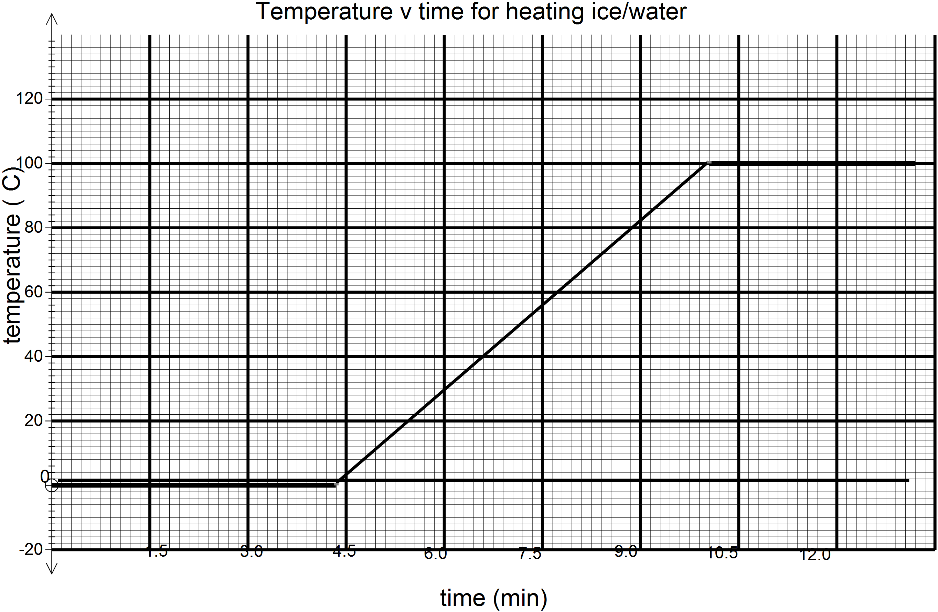

8.35 min

3.71 min

**Question 22** (9 marks)

(a)

It is likely that the plastic thickness has decreased allowing a greater quantity of radiation to pass through it. (1 mark)

(b)

Beta radiation can be stopped from penetrating thin sheets of aluminium so the MINIMUM protection would be for the source to be housed in a covering of aluminium. (2 marks)

(c)

0 to 5.3 years = 5.3 years

5.3 to 10.6 years = 5.3 years

10.6 to 15.9 years = 5.3 years

Average = 15.9 / 3 = 5.3 years

The half life is 5.3 years (3 marks)

(d) Yes (1 mark)

The beta emitter would produce radiation that would penetrate the plastic and a half life of

5.3 years would be suitable as the source would not need to be changed too often. (2 marks)

**Question 23**  (8 marks)

(a)

 (3 marks)

(b)

a = 4.5 / 3.5 m s-2

= 1.29 m s-2 (1 mark)

(c)

F = m x a

F = 2.5 x 1.29 = 3.23 N (1 mark)

(d)

E = ½ m v2

E = ½ x 2.5 x 4.52 = 25.3 J (2 marks)

(e)

P = E / t = ½ m v2 / t

P = ½ x 2.5 x 4.52 / 3.5

= 7.23 W (1 mark)

(f)

P = 0 W (1 mark)

**Question 24** (9 marks)

(a) Let final equilibrium temperature = Tf

Heat gained by the ice

m c ΔT + m L + m c ΔT

(0.02 x 2.10 x 103 x 15) + (0.02 x 3.34 x 105) + [(0.02 x 4.18 x 103 x (Tf – 0)]

630 + 6680 + 83.6 Tf

Heat lost by the water and calorimeter

mw x c ΔT + mcu c ΔT

[0.085 x 4.18 x 103 x (40 – Tf)] + [(0.05 x 3.87 x 102 x (40 – Tf)]

14 212 - 355.3 Tf + 774.0 -19.3 Tf

Heat lost = Heat gained

14 212 – 355.3 Tf + 774.0 - 19.3Tf = 630 + 6680 + 83.6 Tf

-355.3Tf – 83.6 Tf - 19.3 Tf = 630 + 6680 -14 212 - 774.0

-458.2Tf = -7676

Tf which is the equilibrium temperature is 16.8 oC (6 marks)

(b) Higher (1 mark)

(c)

Aluminium (910 J kg-1 K-1) has a higher specific heat capacity than copper (387 J kg-1 K-1). Therefore the final temperature will be higher. The initial heat contained in the aluminium calorimeter plus water would be greater therefore the temperature would be maintained at a higher level. (2 marks)

**Question 25** (7 marks)

1. Circle 1: ‘V’ as the circle represents a voltmeter connected in parallel across the

component it is measuring potential difference. (1 mark)

1. Circle 2: ‘A’ as the circle represents an ammeter connected in series with components to

measure the current flowing through the component. (1 mark)

1. 1/R = 1/R1 + 1/R2

1/6 = 1/8 + 1/R

1/R = 1/6 - 1/8

1/R = (4 - 3)/24

R = 24 Ω (2 marks)

1. On the diagram the arrow would be pointing away from the negative terminal of the

power supply. (1 mark)

1. If the total resistance of the circuit is 16 Ω then R3 has a resistance of:

16 - (2 + 6 ) = 8 Ω (2 marks)

(f) V = I x R

9 = I x 16

I = 9 / 16 = 0.56 A (1 mark)

**END OF SECTION 2**

**Section 3:**

Question 25 (16 marks)

1. Ionisation is the separation of an electron from an air molecule. This leaves a positively

charged ion and a negatively charged electron. (2 marks)

1. 241Am95 🡪 237Np93 + 4He2 (2 marks)

note: The equation could include gamma radiation as a product (γ)

1. The smoke particles absorb the alpha particle’s energy and therefore the alpha

particles are less able to ionise in air. (2 marks)

1. Smoke would not stop beta or gamma radiations yet alpha particles are stopped by

smoke. Alpha particles are less penetrating and therefore safer for the user. (3 marks)

1. There is a very small quantity (0.3 µg) of the sample of americium-241 that is capable of emitting gamma radiation and only 1% of all radiation emitted is gamma. (1 mark)

(f) The time taken for the activity of a radioactive source to halve. (2 marks)

(g) So that the device can be used for a relatively long time without the

radioisotope requiring replacement. (2 marks)

(h) Alpha particles are stopped by a few centimetres of air and certainly by the

plastic covering so the radiation is contained within the detector. (2 marks)

**END OF QUESTIONS**